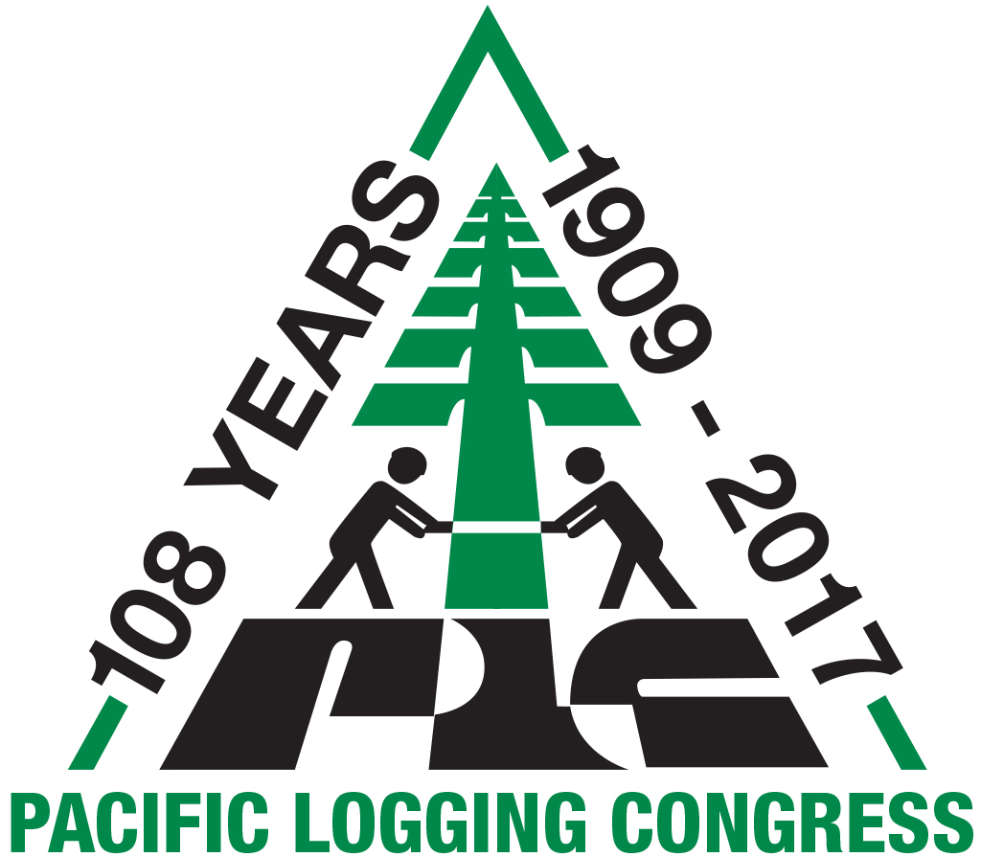
Pacific Logging Congress
& Pacific Forest Foundation
Mailing: P.O. Box 26
Eatonville, WA 98328

For Media Inquiries, Contact:
Diane Mettler
Phone:360-832-1745
diane@pacificloggingcongress.com

FOR IMMEDIATE RELEASE

Pacific Logging Congress Announces Four New Board Members

Eatonville, WA. (December 10, 2017) — The Pacific Logging Congress (PLC), an association of forestry contractors, mill managers, and timberland owners, dedicated to supporting the future of logging and the forest industry, welcomes four new board members.

Lindsay Baska, office manager at Mike Pihl Logging, has grown up on the company. She started working in the office when she was in high school. She enjoys learning about the history of the industry from her dad, Mike Pihl.

Larry Heesacker owns and operates A-1 Logging Inc. out of Yamhill, Oregon. Larry started out in 1985 with a chainsaw and a pick-up truck. Today, Larry, with his wife Donna, have built a solid reputation as one of Yamhill County’s most trusted loggers.

Peter Jackson, a licensed land surveyor and a professional forester, has been employed by Green Diamond Resource Company for almost two decades. Pete also serves on the Blue Lake Fire Protection District Board of Directors, and the Mountain Western Log Scaling and Grading Bureau Board of Directors.

Anthony Roberts is the associate publisher of Logging and Sawmilling Journal and TimberWest Magazine. Anthony’s 10-year career in forestry and natural resource management includes project management, consulting, operational planning, harvesting, mining, and geographic information systems

“Each of these individuals embodies the spirit and goals of the PLC,” says PLC President, Jeff Wimer. “They bring with them talent, expertise and energy and will be a great asset. We’re excited to have them on board.”

About Pacific Logging Congress
The Pacific Logging Congress is an association of representatives from the forest management, harvesting and production side of the forest industry in the Western United States, British Columbia, and New Zealand. Members consists of managers, owners of logging companies, lumber mills, forest products companies, equipment manufacturers and dealers. www.pacificloggingcongress.com

# # #

