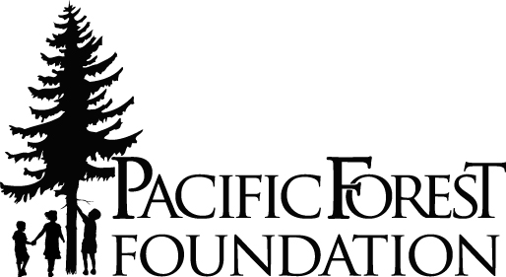

Pacific Logging Congress
& Pacific Forest Foundation
Mailing: P.O. Box 26
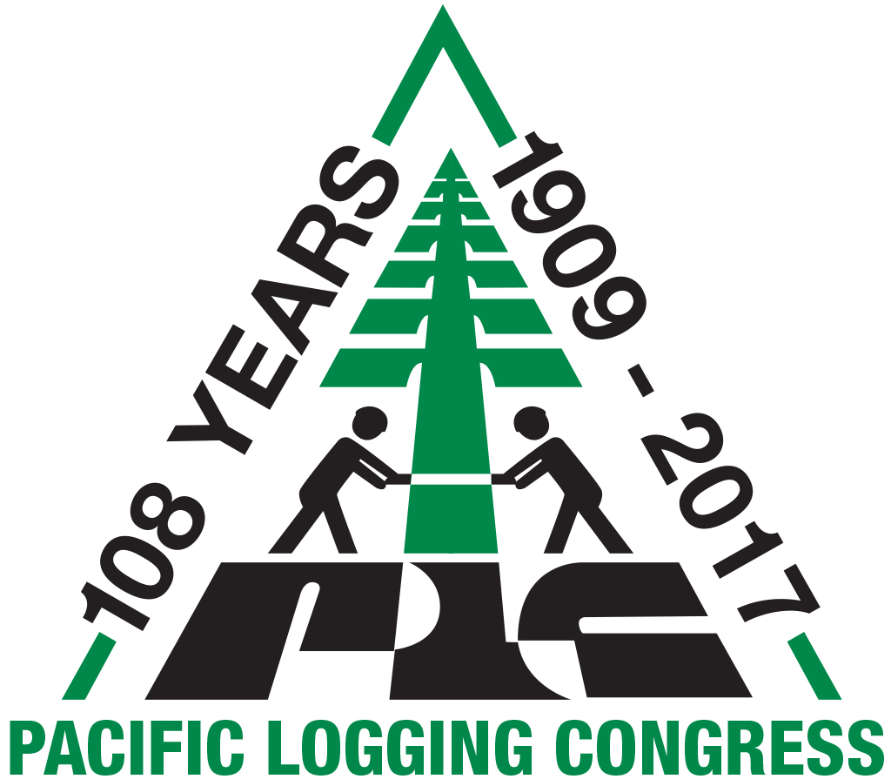
Eatonville, WA 98328

For Media Inquiries, Contact:
Diane Mettler
Phone:360-832-1745
diane@pacificloggingcongress.com

FOR IMMEDIATE RELEASE

Pacific Logging Congress Launches Adopt A High School Program

Eatonville, WA. (November 15, 2017) — The Pacific Logging Congress (PLC), an association of forestry contractors, mill managers, and timberland owners, dedicated to supporting the future of logging and the forest industry, launched its Pacific Forest Foundation Adopt A High School program, at PLC’s annual conference in Scottsdale, Arizona.

Creating new programs is nothing new to the PLC, which previously developed the It Takes a Tree program, a science-based, elementary education program for public school teachers, and created the award-winning This is My Office video designed to make students aware of the opportunities available in the industry. The PLC also brings thousands of students to its Live In-Woods Show every four years. Now the PLC has launched the Adopt A High School program.

A Need and a Solution
“We saw a growing need for both logging companies and students,” says Joe Miller, PLC President and Trinity River Logging timber manager. “Logging and trucking companies with an aging workforce were finding it difficult to fill positions. And students with vocational leanings were unaware of the opportunities in the forest industry. We think we found an answer.”

The Program
The Adopt A High School (AAHS) program was designed to help loggers recruit, develop and retain local novice talent. The PLC conducted a one-year pilot in 2016/17, and with feedback from contractors, honed the contractor-driven apprenticeship program.

“With our aging workforce, we came up with this idea of recruiting back into the schools,” says Roger Smith, PLC board member, and the contractor who initiated the program. “With today’s technology, there is going to be a lot of cool jobs for the next generation of loggers, mill owners, and equipment dealers — everyone in forestry. They should feel proud to join this great industry.”

Today, the simple and structured program is ready to be used by any logging or trucking contractor. The AAHS allows companies to develop a clear understanding of their workflow and expectations, and helps companies select qualified candidates without going through multiple job applications and cumbersome program periods.

Tools at Your Finger Tips
All the tools necessary for contractors to get started are located on the PLC and PFF websites. Included are: (1) a self-directed toolbox providing contractors with new ways to present their business and their employment opportunities in a positive, professional way; (2) an adaptable power point presentation and student handouts; and (3) a template letter on introduction for contractors to reach out to schools. As more tools are developed they will be added to the websites.

“This is a way to promote your company and the industry to your local area,” says Smith. “It is a simple program to use.”

Instead of waiting for students to find forestry jobs, Adopt A High School brings the jobs to the students, creates awareness, and creates the industry employees of tomorrow.

To learn more about the Pacific Logging Congress or the Pacific Forest Foundation, visit https://www.pacificloggingcongress.org or http://www.pacificforestfoundation.org.

About Pacific Logging Congress
The Pacific Logging Congress is an association of representatives from the forest management, harvesting and production side of the forest industry in the Western United States, British Columbia, and New Zealand. Members consists of managers, owners of logging companies, lumber mills, forest products companies, equipment manufacturers and dealers.

About Pacific Forest Foundation
The Pacific Forest Foundation (PFF) is a nonprofit foundation formed in 2003 dedicated to public education about forests and forestry issues. The PFF programs provide information about a balance between forest management and environmental protection. Each year the foundation provides critical scholarships and educational opportunities to forestry students.

# # #

